DEPARTMENT OF COMPUTER SCIENCE AND ENGINEERING
ACHARYA INSTITUTE OF TECHNOLOGY
(Affiliated to Visvesvaraya Technological University, Belagavi, Recognized by AICTE, New Delhi)
Acharya Dr. Sarvepalli Radhakrishnan Road, Soldevanahalli, Bengaluru - 560107
2024 - 2025

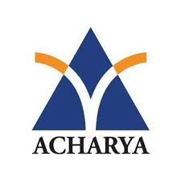

Certificate

This is to certify that the Technical Seminar (21CS81) entitled “Generative AI Meets Traditional NLP: A Hybrid Approach for Robust Text Generation and Analysis” carried out by Anish Kumar (USN 1AY21CS028), is bonafide student of Acharya Institute of Technology, Bengaluru in partial fulfillment for the award of the degree of Bachelor of Engineering in Computer Science and Engineering of the Visvesvaraya Technological University, Belagavi during the year 2024-25. It is certified that all corrections/suggestions indicated for Internal Assessment have been incorporated in the report deposited in the departmental library. The Technical Seminar report has been approved as it satisfies the academic requirements in respect of Technical Seminar prescribed for the said Degree.

Signature of Guide | Signature of Technical Seminar Co-Ordinator | Signature of HOD
(Prof. Sneha N P) | (Prof. Anitta) | (Prof. Rajeev Bilagi)
(Assistant Professor, CS&E)

